

# Computer & Electronic Engineering

# Final Year Project "Music Host Interface"

# Sprint 7: Week 2 Log

# Thomas Flynn

# Project Supervisor: Brian O'Shea

# 21/03/16 - 27/03/16

# 1 Log Entries

## 1.1 Entry 1: 23/03/16

Today I spent a lot of time implementing my custom browser into my application. After much frustration I was successfully able to do this. The custom Browser demonstrates how a JavaFX application can run side by side with a browser. My intention was to use the power of the WebEngine to run a Javascript that would download a Youtube video as an mp3 so I could create my own song object. Not only did this prove to be quite difficult but it also turned out to be illegal!

I then spent another hour trying to get JavaFX mediaView to play a Youtube video but this also didn't work as webView doesn't support HTTPS.

I spent the last hour researching Google's Youtube Data API. The process to get credentials seemed arduous and time consuming. If I had thought of the idea of playing Youtube videos earlier on in the development of my project I think I would have managed to incorporate this excellent feature. The feature would have essentially given the Android client an unlimited selection of songs to choose from (provided the music host enabled the Youtube request feature).

My progress today won't be in vein however as I will use my custom web browser object and basic Javascripts to request the top 40 songs on the charts. I don't particularly care about this feature but it's relevant to the project and it will improve my grade. At the very least it demonstrates a powerful feature of JavaFX.

## 1.2 Entry 2: 24/03/16

Today I spent most of my time reconfiguring my server. I moved my server thread code to the main controller screen. This has the advantage of simplifying my design. However it also means that I probably won't be able to update the DJ scene from the server thread.

The main goal that was accomplished today was the thread safe closing of the connection thread. I spent good bit of time online reading about threading in order to get this to work. This milestone allows me to more easily test communication with the Android client as I can simply reconnect every time.

## 1.3 Entry 3: 25/03/16

Today I added both a swipe feature and an expandable list feature to my Android project. The swipe feature wasn't too difficult to implement. It just took time. The expandable list feature was difficult however. (The expandable list holds the song Queue which is separate from the selection list. The reason for adding this feature was to allow the user to see how many votes a song has in the child of the parent).

## 1.4 Entry 4: 26/03/16

Today I worked on getting Azure mobile services to work on my Android app as well as a simple shared preference toast.

## 1.5 Entry 5: 27/03/16

I underestimated the challenge of adding the mobile services to my application. I was able to get the basic example working but I kept breaking the code. I ended up spending far too much time on this feature with little to show for it.

I spent a lot of time doodling on paper on how to implement the communication protocol between client and server. These doodles will be appended at the back of this log book.

# 2 Task completed:

Custom region in FX that holds web browser and runs java script.

Realised I can't illegally pirate songs from youtube.

Wait thread creates separate runnable thread for connection.

Server connection disconnects and restarts after communication has ended.

Read int working with FX

Activity 2 can swipe left and right

Songqueue expandable

Server has multiple responses

Songqueue expandable adapter class

Load shared preferences

Mobile services example working

Doodled bluetooth communication interface

# 3 GIT Repositories:

## 3.1 -FYP-Android

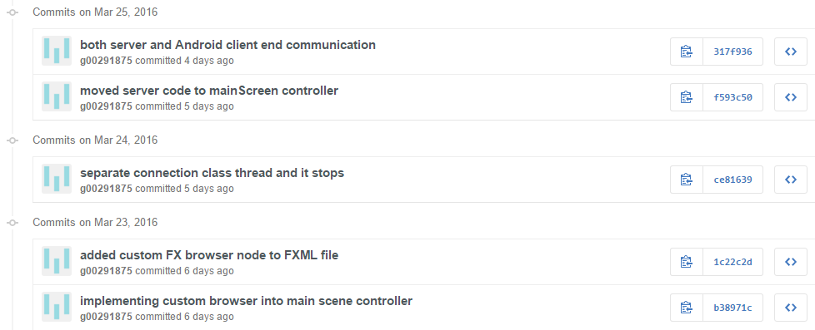

## 3.2 -FYP-GUI

## C:\year 5\Project Year 5 Documentation\Weekly screenshots\Sprint 7\wk2\gitfx.PNG

# 4 Trello boards

## 4.1 Board at the start of the week:

## C:\year 5\Project Year 5 Documentation\Weekly screenshots\Sprint 7\wk1\boardend.PNG

## 4.2 Board at the end of the week:

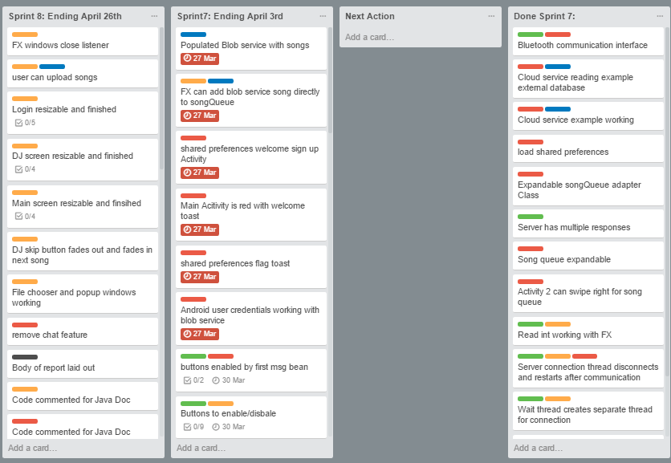

# 5 Toggl Time Logs

## 5.1 Weekly time Log bar chart:

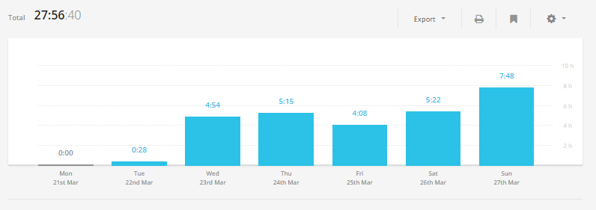

## 5.2 Weekly Time Log:

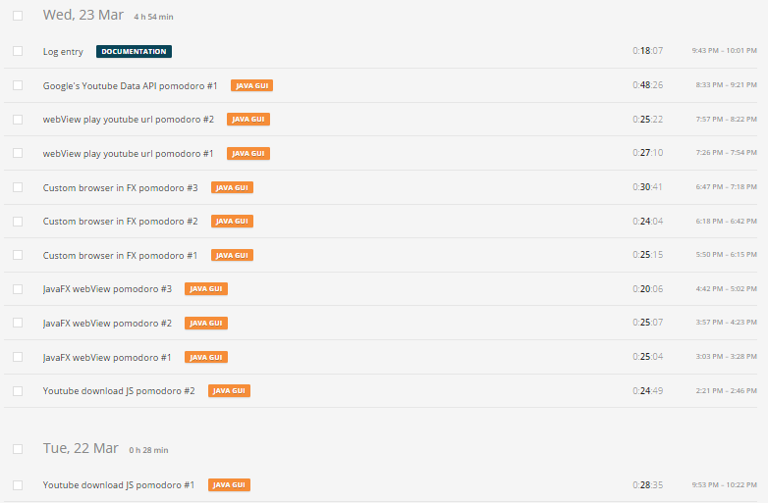

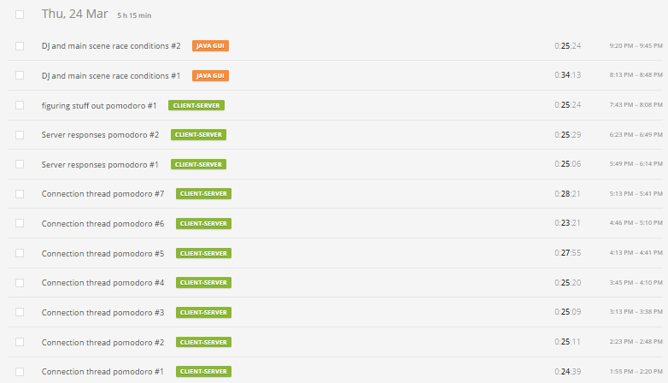

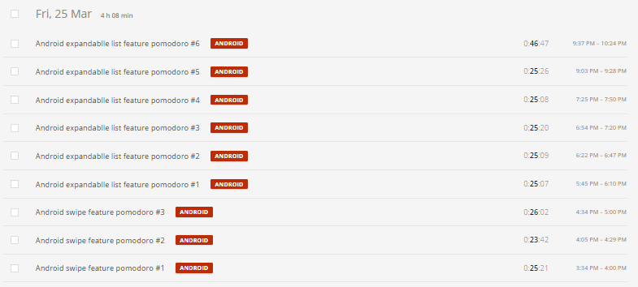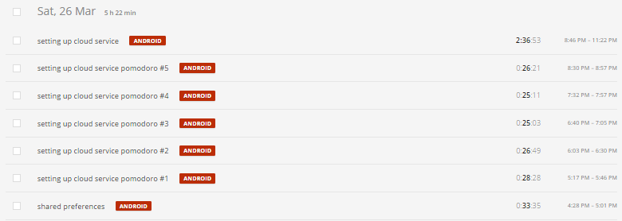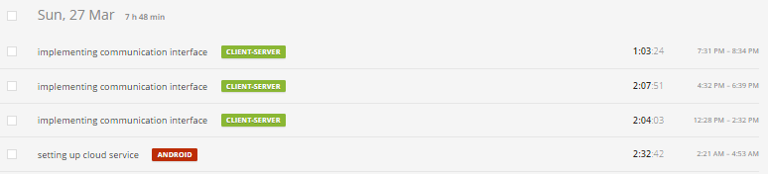

## 5.3Weekly log Pie Charts:

